|  |  |  |
| --- | --- | --- |
| SCHOOL OF INFORMATION AND TECHNOLOGY | | |
| NAME: Hyra Cayambas | DATE PERFORMED: 10/16 |  |
| Section: IDC1 | DATE SUBMITTED: 10/16 |

# SYSADM1 – Web Server Monitoring

1. How do you monitor web server statistics?

There are a variety on web server monitoring tools available online that look out for data such as uptime, response times, resource usage, request rates, and error logs. Web server logs can also be parsed for information about requests and errors. One simple way to monitor web server statistic is through the native performance monitor of the server and specifying “web server” as the counter. This tool keeps track of bytes sent, received and transferred and even the processor information of your computer being utilized by the web server.

1. What are the key metrics that you need to monitor in a web server?

The important metrics that we should monitor on a web server are; response time, request per second, the CPU usage of the server, memory usage, the error rate and the uptime metrics of the web server.

Analyze the provided web server statistics to determine what is being asked for below.

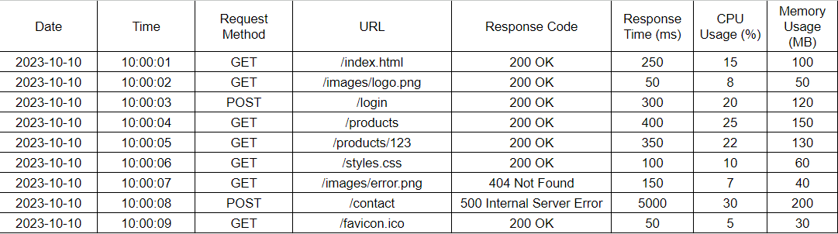

1. Average response time: (250 + 50 + 300 + 400 + 350 + 100 + 150 + 5000 + 50) / 9 = 664.44ms
2. Request per second: 9 requests / 8 seconds = 1.125 requests per second.
3. Memory usage: (100 + 50 + 120 + 150 + 130 + 100 + 40 + 150 + 30) / 9 = 96.67MB
4. Error rate: (2 errors / 9 requests) * 100 = 22.22%
5. Common error types:

404 Not Found: requested resource could not be found.

500 Internal Server Error: issue on the server side.

1. What are the possible issues in the web server statistics above?

There is one instance where the response time was 5000ms or 5 seconds and even returned the error code 500. This could indicate that this endpoint might be overloaded or malfunctioning. Additionally, an error rate of 22.22% is relatively high, and the combination of 404 error and 500 error suggests that both resource availability and server stability should be investigated.

The CPU usage is higher during the 500 error request showing CPU and memory spikes, which might mean a problem with resource management for that particular request. Memory usage is also relatively high for some requests, suggesting potential resource inefficiency.

**Grading Rubric**

|  |  |  |
| --- | --- | --- |
| Criteria | Points | Description |
| Monitoring methods | 10 | Demonstrates understanding of various methods for monitoring web server statistics (e.g., using tools, server logs, performance counters). |
| Key Metrics | 10 | Identifies the correct key metrics to monitor (e.g., response time, traffic, error rates, resource usage). |
| Data Analysis | 30 | Accurately calculates average response time, requests per second, memory usage, error rate, and identifies common error types. |
| Issues Identification | 10 | Accurately identifies potential issues based on the analyzed statistics (e.g., high error rates, resource constraints). |
| Total | /60 |  |